WEEK 2 — Data Visualization and Insight Communication Using R
Introduction
The objective of this task is to create informative and meaningful visualizations using R and communicate important patterns and insights from the Titanic passenger dataset. Building on the data cleaning and preprocessing performed in Week 1, this analysis uses different visualization techniques to explore distributions, comparisons, relationships, and survival patterns. R and the ggplot2 visualization library were used to create clear and professional graphs suitable for both technical and non-technical audiences.
Dataset Overview
The Titanic passenger dataset was selected for this analysis. The dataset contains information about 891 passengers and 12 variables, including passenger class, survival status, gender, age, number of siblings or spouses, number of parents or children, fare, cabin and port of embarkation. The cleaned dataset from Week 1 was used for visualization so that missing values and extreme Fare values had already been addressed.
Visualization Methodology
Different visualization techniques were selected according to the type of variable and the analytical question being investigated. Histograms were used to examine the distribution of numerical variables such as Age and Fare. Bar charts were used to compare categorical groups such as gender and passenger class. Scatter plots were selected to investigate relationships between two numerical variables. A correlation heatmap was used to provide an overall view of relationships among numerical variables. The ggplot2 package in R was primarily used because it provides flexible and clear methods for creating publication-quality visualizations.
Data Visualizations and Analysis
Age Distribution of Titanic Passengers:
A histogram was selected to visualize the distribution of passenger ages. Histograms are useful for numerical variables because they group continuous values into intervals and display the frequency of observations in each interval. This visualization helps identify the most common age ranges, the spread of ages, and the overall shape of the distribution.
library(ggplot2)
ggplot(data, aes(x = Age)) +
geom_histogram(
bins = 30,
fill = "steelblue",
color = "white"
) +
labs(
title = "Age Distribution of Titanic Passengers",
x = "Age",
y = "Number of Passengers"
) +
theme_minimal()
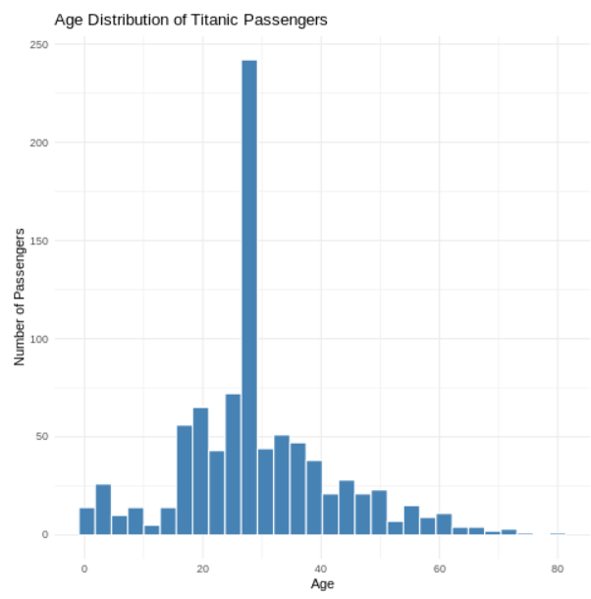
The histogram shows that passengers were distributed across a wide age range, from infants to approximately 80 years. The highest concentration of passengers is around the 20–30 age range, with the age of approximately 28 having the highest frequency. The number of passengers generally decreases as age increases beyond the 30–40 range. Therefore, the dataset contains a larger proportion of young and middle-aged passengers compared with older passengers.
Survival Status by Gender:
A grouped bar chart was selected to compare the survival status of male and female passengers. Since Gender is a categorical variable and Survival Status has two categories, a bar chart provides a clear comparison of the number of passengers who survived and did not survive within each gender.
library(ggplot2)
ggplot(data, aes(x = Sex, fill = factor(Survived))) +
geom_bar(position = "dodge") +
labs(
title = "Survival Status by Gender",
x = "Gender",
y = "Number of Passengers",
fill = "Survival Status"
) +
scale_fill_manual(
values = c("0" = "gray", "1" = "steelblue"),
labels = c(
"0" = "Did Not Survive",
"1" = "Survived"
)
) +
theme_minimal()
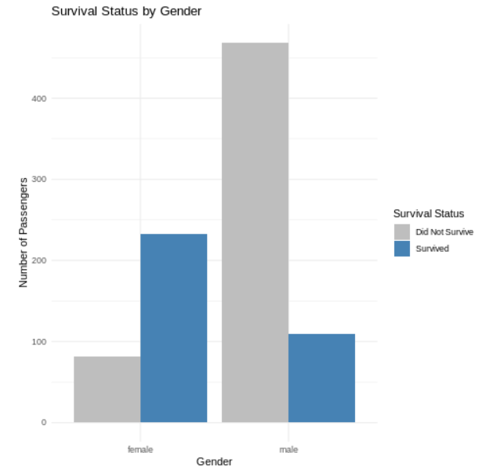
The visualization shows a clear difference in survival between male and female passengers. Among female passengers, the number of survivors is considerably higher than the number who did not survive. In contrast, among male passengers, the number of passengers who did not survive is much higher than the number who survived. This indicates a strong association between gender and survival in the Titanic dataset.
Survival Rate by Passenger Class:
A bar chart was selected to compare the survival rates of passengers belonging to different passenger classes. The Pclass variable represents First Class, Second Class, and Third Class. Comparing survival rates across these categories helps identify whether passenger class was associated with survival.
class_rate <- aggregate(
Survived ~ Pclass,
data = data,
FUN = mean)
class_rate$Survival_Rate <- class_rate$Survived * 100
print(class_rate)
library(ggplot2)
ggplot(
class_rate,
aes(
x = factor(Pclass),
y = Survival_Rate)
) +
geom_col(fill = "steelblue") +
labs(
title = "Survival Rate by Passenger Class",
x = "Passenger Class",
y = "Survival Rate (%)"
) +
theme_minimal()
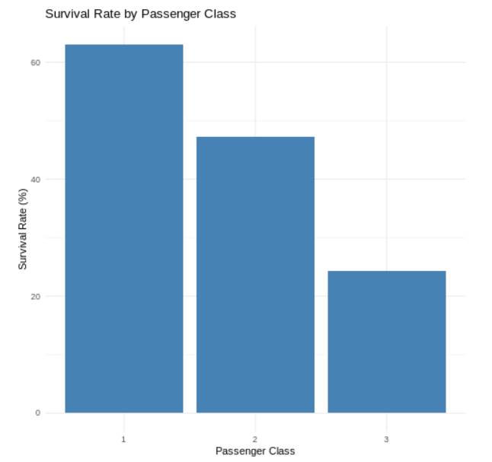
The visualization shows a clear difference in survival rates across passenger classes. First Class passengers had the highest survival rate, followed by Second Class passengers, while Third Class passengers had the lowest survival rate. The survival rate was approximately 63% for First Class, 47% for Second Class, and 24% for Third Class. This indicates a strong association between passenger class and survival.
Fare Distribution After Outlier Treatment:
library(ggplot2)
ggplot(data, aes(x = Fare_capped)) +
geom_histogram(
bins = 30,
fill = "darkgreen",
color = "white"
) +
labs(
title = "Fare Distribution After Outlier Treatment",
x = "Fare",
y = "Number of Passengers"
) +
theme_minimal()
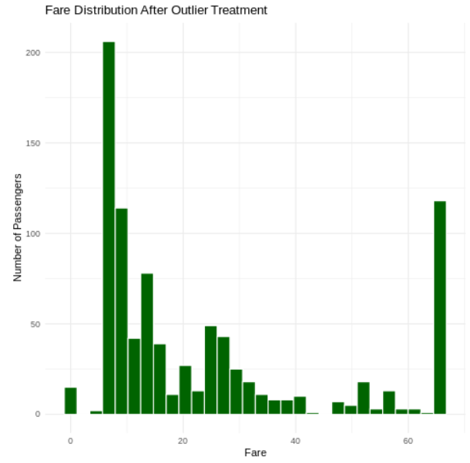
The histogram shows that most passengers paid relatively low fares, with the highest concentration occurring at the lower end of the fare range. The distribution is positively skewed, meaning that fewer passengers paid higher fares. After outlier treatment, the extreme fare values were capped at the calculated upper limit of 65.6344. This reduces the influence of unusually high fares while retaining the passenger records for further analysis.
Relationship Between Age and Fare:
library(ggplot2)
ggplot(
data,
aes(
x = Age,
y = Fare_capped
)
) +
geom_point(alpha = 0.5) +
geom_smooth(
method = "lm",
se = TRUE
) +
labs(
title = "Relationship Between Age and Fare",
x = "Age",
y = "Fare"
) +
theme_minimal()
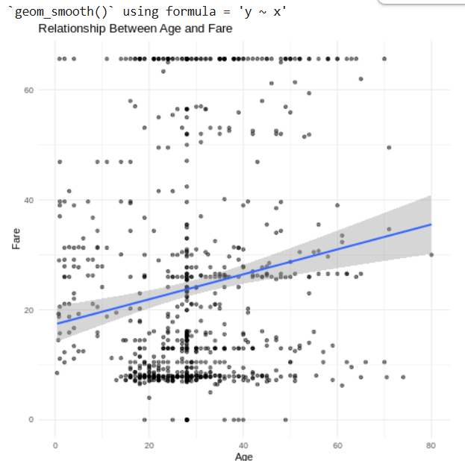
The scatter plot shows a large amount of variation in fare across different age groups. Most observations are concentrated in the lower fare range, while some passengers paid considerably higher fares. The regression line has a positive slope, suggesting a weak positive relationship between Age and Fare. However, the points are widely scattered around the trend line, indicating that age alone does not strongly explain the variation in fare.
Survival by Passenger Class and Gender:
library(ggplot2)
ggplot(
data,
aes(
x = factor(Pclass),
fill = factor(Survived)
)
) +
geom_bar(position = "dodge") +
facet_wrap(~Sex) +
labs(
title = "Survival by Passenger Class and Gender",
x = "Passenger Class",
y = "Number of Passengers",
fill = "Survival Status"
) +
theme_minimal()
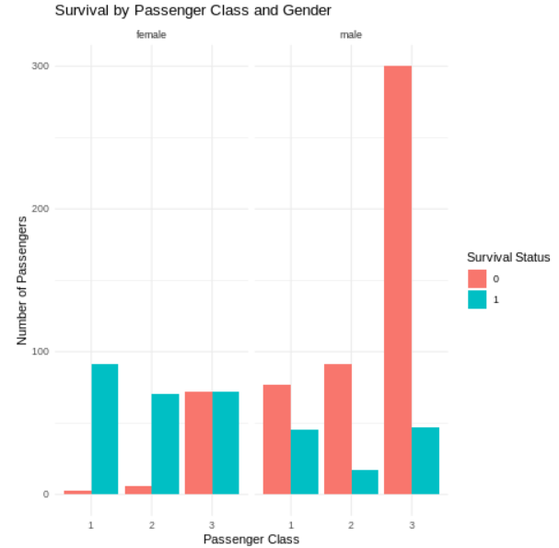
The visualization shows clear differences in survival patterns based on both gender and passenger class. Female passengers in First and Second Class had considerably more survivors than non-survivors. In Third Class, the numbers of female survivors and non-survivors were more similar. Among male passengers, non-survivors were substantially higher than survivors, particularly in Third Class. Overall, the visualization suggests that both gender and passenger class were important factors associated with survival.
Correlation Heatmap:
cor_data <- data[, c(
"Survived",
"Pclass",
"Age",
"SibSp",
"Parch",
"Fare_capped"
)]

cor_matrix <- cor(
cor_data,
use = "complete.obs"
)

heatmap(
cor_matrix,
main = "Correlation Heatmap",
symm = TRUE
)
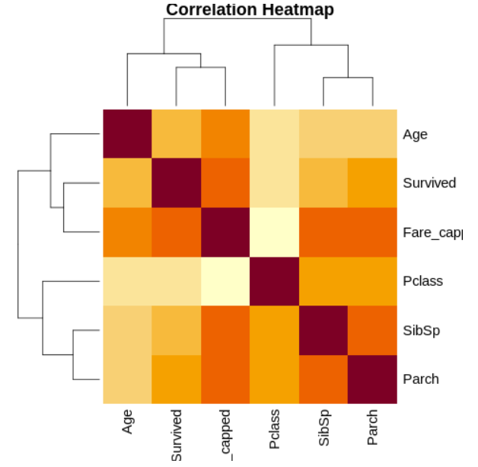
The heatmap shows that Pclass has a moderate negative relationship with Survived, while Fare_capped has a moderate positive relationship with Survived. Age, SibSp and Parch have relatively weak relationships with survival. The visualization also shows relationships among the other numerical variables, such as the relationship between SibSp and Parch.
Key Insights
The visualizations provided several important insights into the Titanic dataset. The age histogram showed that most passengers were concentrated in the younger and middle-age ranges, particularly around 20–30 years. The survival-by-gender visualization showed a substantial difference between male and female passengers, with female passengers having a much higher survival rate. Passenger class also showed a clear relationship with survival, with First Class passengers having the highest survival rate and Third Class passengers having the lowest.
The fare distribution showed that most passengers paid relatively lower fares, while a smaller number paid higher fares. The scatter plot of Age and Fare showed a positive trend but considerable variation, indicating that age alone does not strongly explain fare differences. The combined class-and-gender visualization provided further evidence that survival patterns differed according to both passenger class and gender. Finally, the correlation heatmap showed that Pclass and Fare_capped had stronger relationships with survival compared with Age, SibSp and Parch.
Conclusion
This visualization analysis demonstrated how different graphical techniques can be used to communicate patterns in a real-world dataset. Histograms were useful for understanding numerical distributions, bar charts enabled comparisons between categorical groups, scatter plots helped examine relationships between numerical variables, and the correlation heatmap summarized relationships among multiple variables. The analysis showed important survival differences based on gender and passenger class and provided a clearer understanding of the characteristics of Titanic passengers. These visual insights can support the statistical analysis and predictive modeling performed in the next stage of the project.
Complete R Code
library(ggplot2)
ggplot(data, aes(x = Age)) +
geom_histogram(
bins = 30,
fill = "steelblue",
color = "white"
) +
labs(
title = "Age Distribution of Titanic Passengers",
x = "Age",
y = "Number of Passengers"
) +
theme_minimal()
ggplot(data, aes(x = Sex, fill = factor(Survived))) +
geom_bar(position = "dodge") +
labs(
title = "Survival Status by Gender",
x = "Gender",
y = "Number of Passengers",
fill = "Survival Status"
) +
scale_fill_manual(
values = c("0" = "gray", "1" = "steelblue"),
labels = c(
"0" = "Did Not Survive",
"1" = "Survived"
)
) +
theme_minimal()
class_rate <- aggregate(
Survived ~ Pclass,
data = data,
FUN = mean
)
class_rate$Survival_Rate <- class_rate$Survived * 100
print(class_rate)
ggplot(
class_rate,
aes(
x = factor(Pclass),
y = Survival_Rate
)
) +
geom_col(fill = "steelblue") +
labs(
title = "Survival Rate by Passenger Class",
x = "Passenger Class",
y = "Survival Rate (%)"
) +
theme_minimal()
ggplot(data, aes(x = Fare_capped)) +
geom_histogram(
bins = 30,
fill = "darkgreen",
color = "white"
) +
labs(
title = "Fare Distribution After Outlier Treatment",
x = "Fare",
y = "Number of Passengers"
) +
theme_minimal()
ggplot(
data,
aes(
x = Age,
y = Fare_capped
)
) +
geom_point(alpha = 0.5) +
geom_smooth(
method = "lm",
se = TRUE
) +
labs(
title = "Relationship Between Age and Fare",
x = "Age",
y = "Fare"
) +
theme_minimal()
ggplot(
data,
aes(
x = factor(Pclass),
fill = factor(Survived)
)
) +
geom_bar(position = "dodge") +
facet_wrap(~Sex) +
labs(
title = "Survival by Passenger Class and Gender",
x = "Passenger Class",
y = "Number of Passengers",
fill = "Survival Status"
) +
theme_minimal()
cor_data <- data[, c(
"Survived",
"Pclass",
"Age",
"SibSp",
"Parch",
"Fare_capped"
)]
cor_matrix <- cor(
cor_data,
use = "complete.obs"
)
print(round(cor_matrix, 3))
heatmap(
cor_matrix,
main = "Correlation Heatmap",
symm = TRUE
)

